Assignment 5

# Description

# BRModule:

BRModule is the bus route module. It is a struct that has a routeName, a point list, and the number of stops on each route. It has a function that will malloc enough memory for the bus route. It also has a function that will add the point scanned to the bus route. Its final function is one that has the ability to get a point on the route using the index.

# Point2D module:

It is a module that has an x and y coordinate for each point. The x and y are double values. Regarding the functions, it has one that will malloc enough memory for the 2d point. It also has one that can free the malloced memory. It has a function that can create a point which will come in handy in other functions. It has one that is able to change the x and y values of an already existing point. It has a function that can modify the x value of an already existing point. It has one that can return the y value of a point. It has a function that can scan a point directly from a file. It also has one that is able to calculate the distance between 2 points. Its final function can copy a point.

# PointList Module

This module has a point list. Each point list has a length and a 2d point array. This module has a function that mallocs enough memory for the whole list. On the other hand, it has a function that frees the malloced memory. It has a function that can change/modify a point that already exists in the list. It also has a function that can return an element in the list.

# Strings Module

The string is an easier, more comprehendible way to look at a char*. Similarly, the stringlist is an easier and more comprehendible way to look at the char**. It has a function that can malloc enough memory for the string. It a function that can free the malloced memory. It has a function that can duplicate a given string. It has a function that, similarly, can duplicate a string array, aka stringlist. It has a function that can compare 2 given strings. It has a function that scans a whole line in the command line (terminal) even with spaces.

# Source code

# BrModule.c

# BRModule.h

# A5.c

# Point2D.h

# Point2D.c

# PointListModule.c

# PointListModule.h

# Strings.c

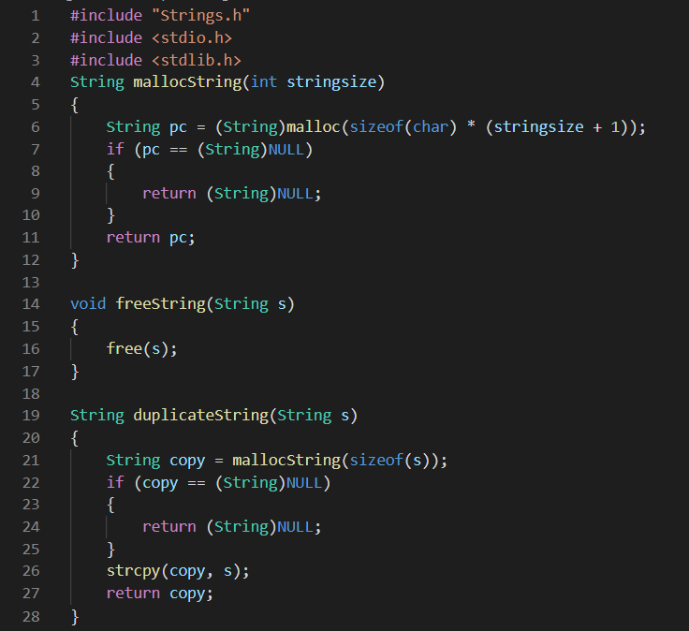

# Strings.h

# StudentModule.c

# StudentModule.h

